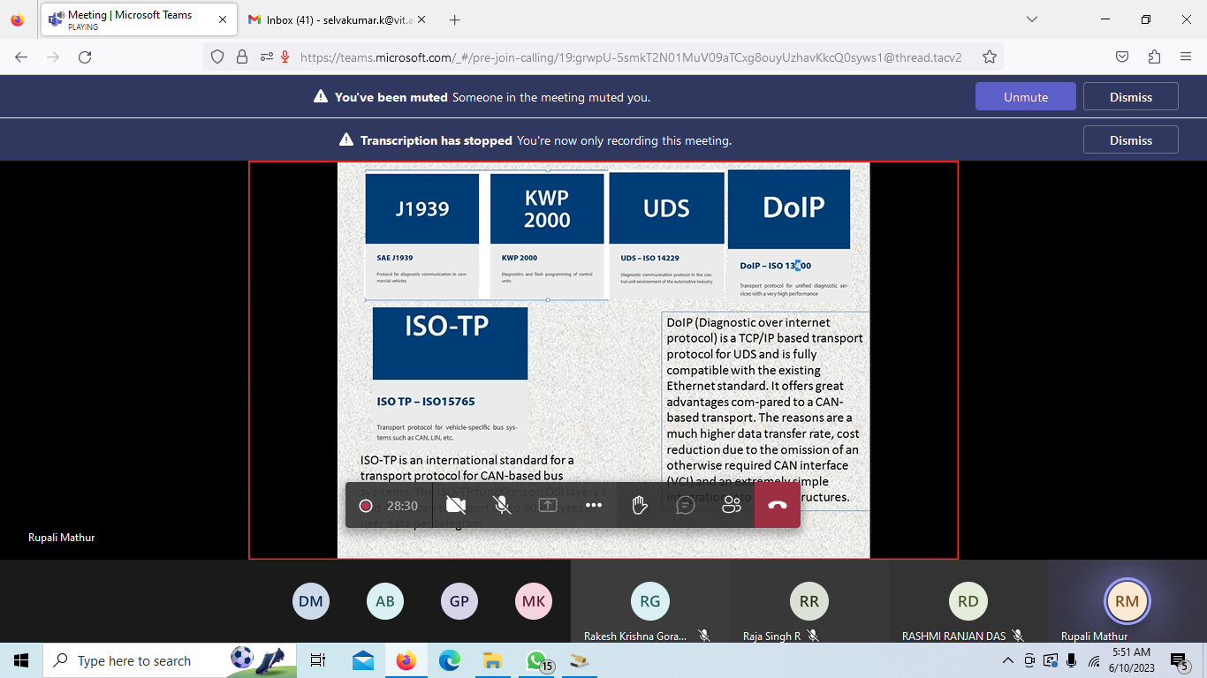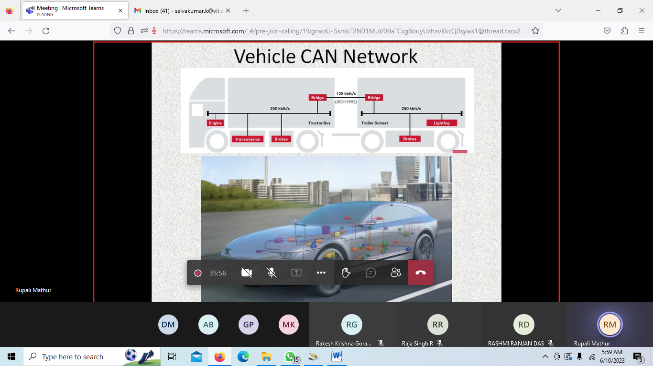

1. Unique source address: Manufacturer specific?
2. CAN FD real need? Use cases?
3. UDS in application layer
4. 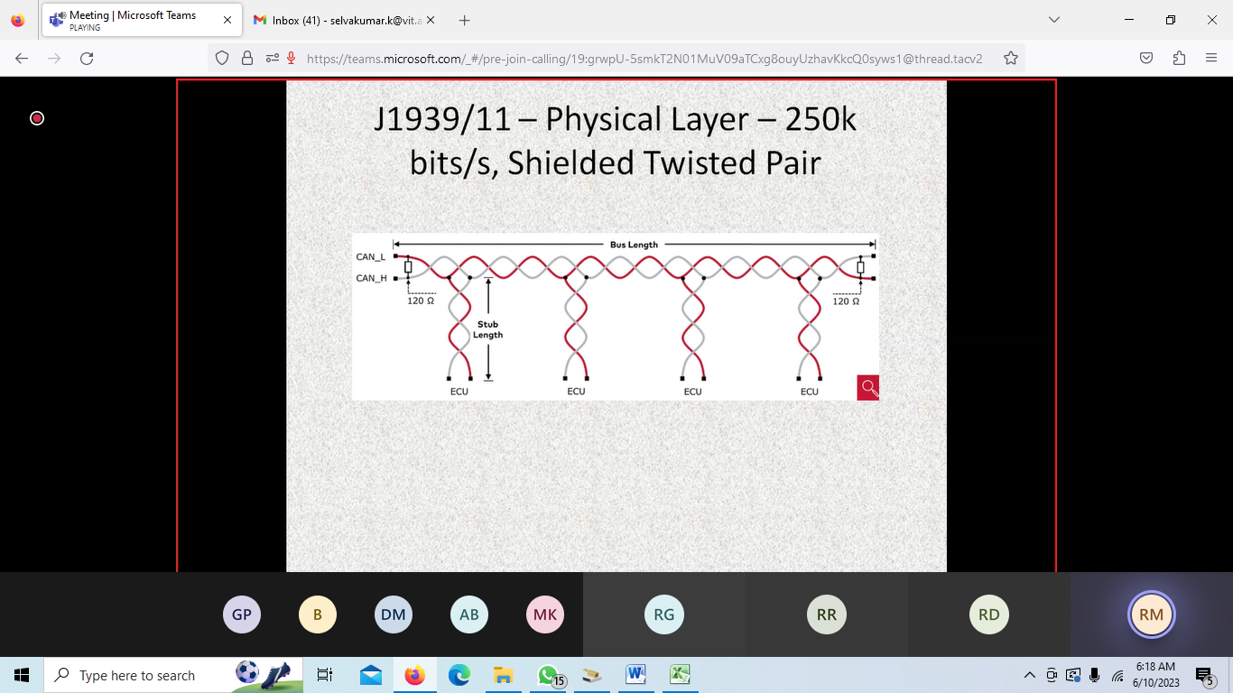
5. J1939-81 address claiming
6. 